**5th April 2016**

**YOKOHAMA Teams Up with Angels for Seventh Straight Season**

SANTA ANA, CA – Yokohama Tire Corporation (YTC) and the Los Angeles Angels are teammates again in 2016, marking the seventh consecutive season in which YTC is a sponsor of the team.

“Our long-standing marketing partnership with the Angels and their fans has been great,” said Alan Holtschneider, YTC director of marketing. “We can’t wait to see what perennial MVP candidate Mike Trout and the team do this year in the American League West division.”

YOKOHAMA’s sponsorship includes its corporate logo in the highly visible position of left centerfield. Holtschneider said the team sponsorship and branding continue to build awareness for Yokohama products among Angels fans.

In addition to the Angels, YOKOHAMA’s 2016 sports sponsorship roster includes the English Premier League Champions Chelsea FC, the Yokohama Tire LPGA Classic and the National Hockey League’s Boston Bruins.

**About Yokohama Tire Corporation**

Yokohama Tire Corporation is the North American manufacturing and marketing arm of Tokyo, Japan-based The Yokohama Rubber Co., Ltd., a global manufacturing and sales company of premium tyres since 1917. Servicing an extensive sales network throughout the U.S., Yokohama Tire Corporation is a leader in technology and innovation. The company’s complete product line includes tyres for high-performance, light truck, passenger car, commercial truck and bus, and off-the-road mining and construction applications.

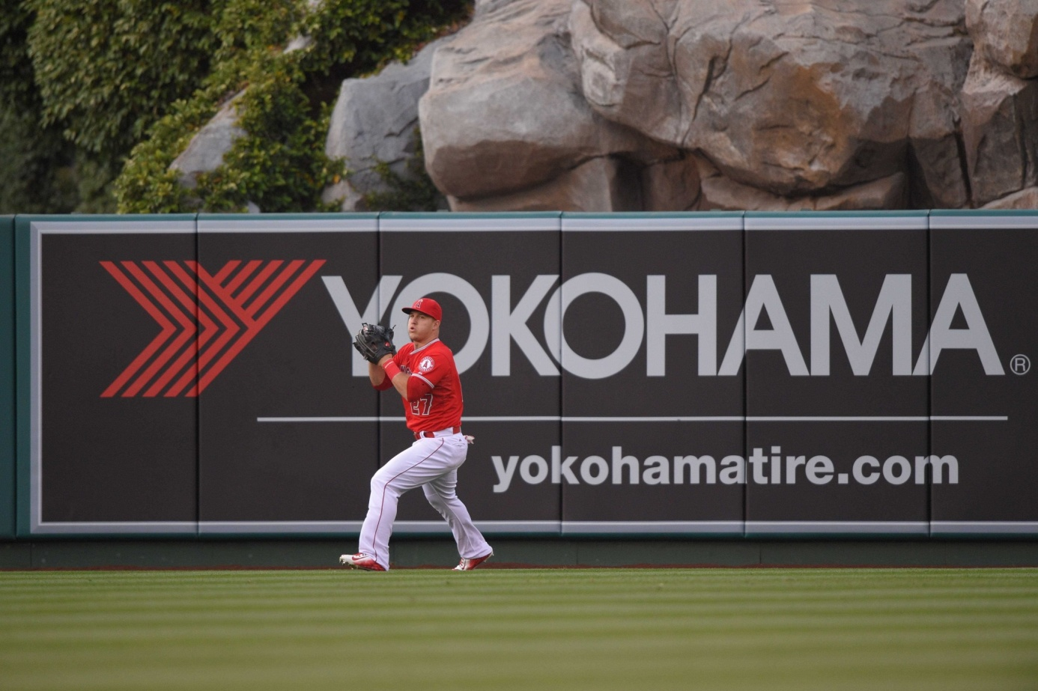

*YOKOHAMA Angels Sponsorship*